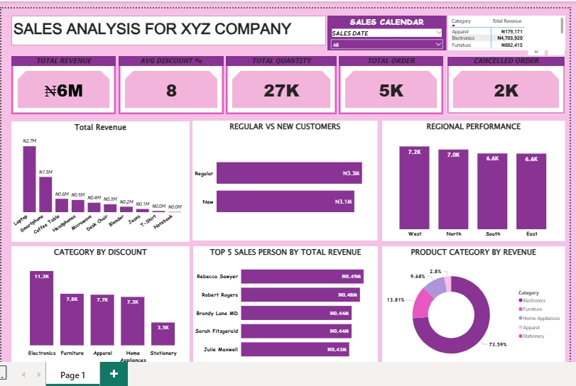

SALES ANALYSIS REPORT FOR XYZ COMPANY

Overview
This report provides a comprehensive overview of the sales performance of XYZ, highlighting key metrics such as total revenue, customer segments, regional performance, product category performance, and discount distribution. The insights are based on data visualized in the submitted dashboard.

1. Key Performance Indicators (KPIs)

Total Revenue: $6M was generated within the reporting period.

Average Discount: The average discount offered across all products and categories is 8%.

Total Quantity Sold: A total of 27,000 units were sold.

Total Orders: XYZ recorded 5,000 orders.

Cancelled Orders: 2,000 orders were reported as cancelled.

2. Revenue Breakdown

Total Revenue by Product: The top contributing products include:
- Laptops: $2.1M
- Coffee Makers: $1.5M
- Mobile Phones: $1.0M
- Headphones: $0.9M
- Microwaves: $0.8M
- Other smaller product lines contribute between $0.3M – $0.5M.
This shows a concentration of revenue in electronics and household appliances.

3. Customer Segmentation: Regular vs New Customers
- Regular Customers: $3.1M
- New Customers: $3.1M
Sales distribution is balanced, indicating strong retention and successful new customer acquisition.

4. Regional Performance
Sales distribution across regions:
- West: 7.2K
- North: 7.0K
- South: 6.8K
- East: 6.6K
The West region leads slightly in sales performance, while the East lags marginally behind.

5. Sales Category by Discount
Categories with the highest average discount:
- Electronics: 11.3K
- Furniture: 7.8K
- Apparel: 7.7K
- Home Appliances: 7.3K
Electronics receive the highest discount levels, likely driving volume.

6. Top 5 Sales Representatives by Revenue
- Rebecca Sawyer – $0.49M
- Robert Rogers – $0.48M
- Brandy Lane MD – $0.46M
- Sarah Fitzgerald – $0.45M
- Julie Maxwell – $0.43M
Rebecca Sawyer leads in performance, closely followed by Robert Rogers.

7. Product Category Revenue Share
Electronics: 71.59% (dominant category)
Furniture: 13.81%
Apparel: 9.48%
Home Appliances: 2.97%
Stationery: 2.15%
Electronics overwhelmingly drive the company's revenue.

Conclusion
XYZ demonstrates strong overall sales performance, with:
- Balanced revenue from both new and regular customers
- Dominant sales in the West region
- Electronics as the key product driver
- A high volume of cancelled orders (2K), which may require further evaluation
The business shows a healthy revenue base and effective customer reach across regions and categories. Strategic improvements can focus on reducing cancellations and optimizing discounts in categories with high markdowns.

